SR UNIVERSITY
M. KOUSHIK REDDY
2103a52153
TASK 1
GIVEN PROMPT
Lab 3: Application for TGNPDCL – Electricity Bill Generation Using Python & AI Tools Lab Objectives • To design a real-world electricity billing application using Python • To use AI-assisted coding tools for logic generation and optimization • To understand conditional logic and arithmetic operations • To generate structured billing output similar to utility bills Lab Outcomes (LOs) After completing this lab, students will be able to: Week2 - Wednesday • Read and validate user input in Python • Apply conditional logic for tariff-based billing • Use AI tools to assist in program development • Calculate and display electricity bill components • Build a complete real-time application. The above is the context Task 1: AI-Generated Logic for Reading Consumer Details Scenario An electricity billing system must collect accurate consumer data. Task Description Use an AI tool (GitHub Copilot / Gemini) to generate a Python program that: • Reads: o Previous Units (PU) o Current Units (CU) o Type of Customer • Calculates units consumed • Implements logic directly in the main program (no functions) Expected Output • Correct input reading • Units consumed calculation • Screenshot showing AI-generated code • Sample input and output we have to do task 1 the details must be created in code itself , about 15 entry every entry must be different ask the questions if u have any doubts
CODE
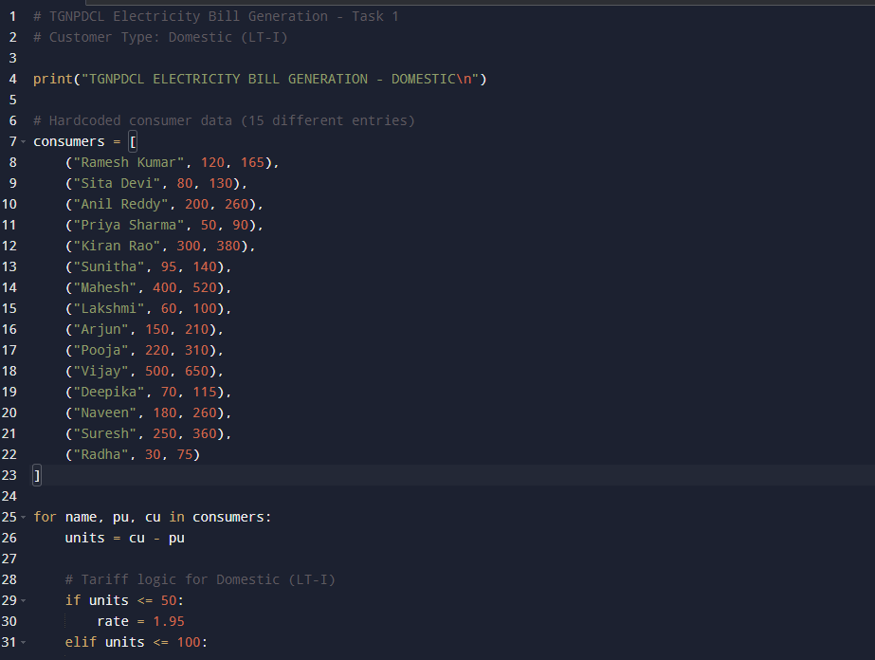
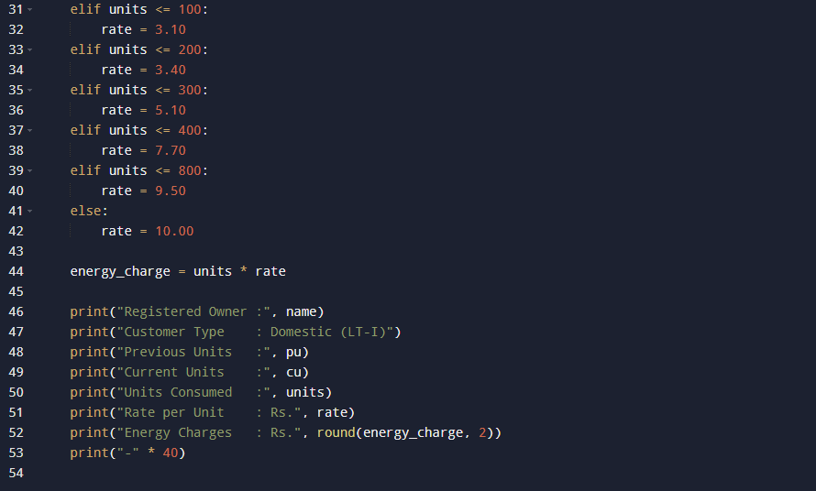
OUTPUT
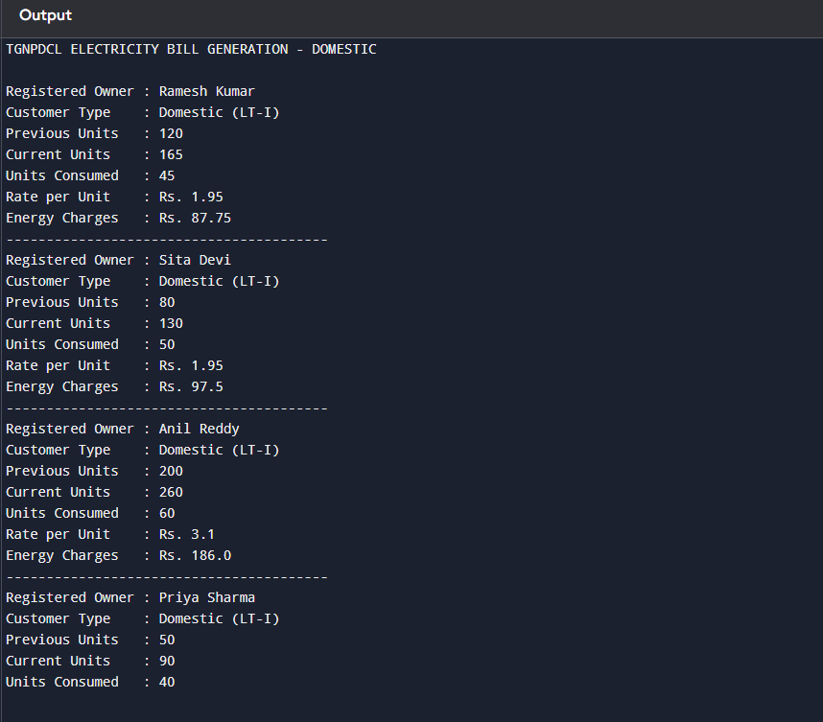
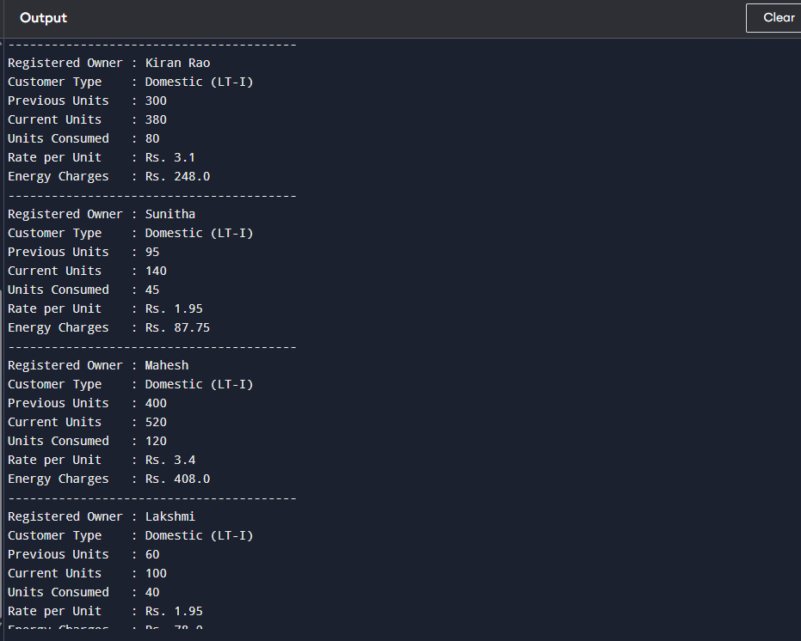
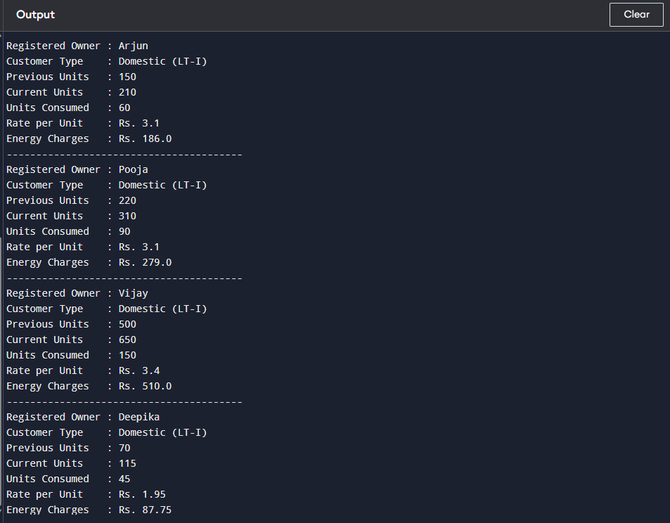
TASK 2
Prompt
Task 2: Energy Charges Calculation Based on Units Consumed Scenario Energy charges depend on the number of units consumed and customer type. Task Description Review the AI-generated code from Task 1 and extend it to: • Calculate Energy Charges (EC) • Use conditional statements based on: o Domestic o Commercial o Industrial consumers • Improve readability using AI prompts such as: o “Simplify energy charge calculation logic” o “Optimize conditional statements” Expected Output • Correct EC calculation • Clear conditional logic • Original and improved versions (optional) • Sample execution results do u understand ask questions
Code
# Task 2: Energy Charges Calculation Based on Units Consumed
# Combined program for Domestic, Commercial, and Industrial consumers

print("TGNPDCL ENERGY CHARGE CALCULATION\n")

# Consumer data: (Name, Previous Units, Current Units, Consumer Type)
consumers = [
("Ramesh Kumar", 120, 165, "Domestic"),
("Sita Devi", 80, 140, "Domestic"),
("Anil Reddy", 200, 260, "Domestic"),
("Priya Stores", 50, 120, "Commercial"),
("City Mart", 300, 420, "Commercial"),
("Sai Industries", 1000, 1180, "Industrial"),
("Lakshmi", 30, 90, "Domestic"),
("Mega Mall", 600, 760, "Commercial"),
("Steel Works", 2000, 2250, "Industrial"),
("Radha", 70, 115, "Domestic"),
("Kiran Shop", 40, 95, "Commercial"),
("Power Plastics", 1500, 1650, "Industrial"),
("Sunitha", 95, 145, "Domestic"),
("Ravi Traders", 110, 190, "Commercial"),
("Agro Mills", 800, 980, "Industrial")
]

for name, pu, cu, ctype in consumers:
units = cu - pu

# Energy Charge calculation based on consumer type
if ctype == "Domestic":
if units <= 50:
rate = 1.95
elif units <= 100:
rate = 3.10
elif units <= 200:
rate = 3.40
elif units <= 300:
rate = 5.10
elif units <= 400:
rate = 7.70
elif units <= 800:
rate = 9.50
else:
rate = 10.00

elif ctype == "Commercial":
if units <= 50:
rate = 7.00
else:
rate = 8.50

elif ctype == "Industrial":
rate = 7.70

energy_charge = units * rate

print("Registered Owner :", name)
print("Consumer Type :", ctype)
print("Previous Units :", pu)
print("Current Units :", cu)
print("Units Consumed :", units)
print("Rate per Unit : Rs.", rate)
print("Energy Charges : Rs.", round(energy_charge, 2))
print("-" * 45)
Output
TGNPDCL ENERGY CHARGE CALCULATION

Registered Owner : Ramesh Kumar
Consumer Type : Domestic
Previous Units : 120
Current Units : 165
Units Consumed : 45
Rate per Unit : Rs. 1.95
Energy Charges : Rs. 87.75
---------------------------------------------
Registered Owner : Sita Devi
Consumer Type : Domestic
Previous Units : 80
Current Units : 140
Units Consumed : 60
Rate per Unit : Rs. 3.1
Energy Charges : Rs. 186.0
---------------------------------------------
Registered Owner : Anil Reddy
Consumer Type : Domestic
Previous Units : 200
Current Units : 260
Units Consumed : 60
Rate per Unit : Rs. 3.1
Energy Charges : Rs. 186.0
---------------------------------------------
Registered Owner : Priya Stores
Consumer Type : Commercial
Previous Units : 50
Current Units : 120
Units Consumed : 70
Rate per Unit : Rs. 8.5
Energy Charges : Rs. 595.0
---------------------------------------------
Registered Owner : City Mart
Consumer Type : Commercial
Previous Units : 300
Current Units : 420
Units Consumed : 120
Rate per Unit : Rs. 8.5
Energy Charges : Rs. 1020.0
---------------------------------------------
Registered Owner : Sai Industries
Consumer Type : Industrial
Previous Units : 1000
Current Units : 1180
Units Consumed : 180
Rate per Unit : Rs. 7.7
Energy Charges : Rs. 1386.0
---------------------------------------------
Registered Owner : Lakshmi
Consumer Type : Domestic
Previous Units : 30
Current Units : 90
Units Consumed : 60
Rate per Unit : Rs. 3.1
Energy Charges : Rs. 186.0
---------------------------------------------
Registered Owner : Mega Mall
Consumer Type : Commercial
Previous Units : 600
Current Units : 760
Units Consumed : 160
Rate per Unit : Rs. 8.5
Energy Charges : Rs. 1360.0
---------------------------------------------
Registered Owner : Steel Works
Consumer Type : Industrial
Previous Units : 2000
Current Units : 2250
Units Consumed : 250
Rate per Unit : Rs. 7.7
Energy Charges : Rs. 1925.0
---------------------------------------------
Registered Owner : Radha
Consumer Type : Domestic
Previous Units : 70
Current Units : 115
Units Consumed : 45
Rate per Unit : Rs. 1.95
Energy Charges : Rs. 87.75
---------------------------------------------
Registered Owner : Kiran Shop
Consumer Type : Commercial
Previous Units : 40
Current Units : 95
Units Consumed : 55
Rate per Unit : Rs. 8.5
Energy Charges : Rs. 467.5
---------------------------------------------
Registered Owner : Power Plastics
Consumer Type : Industrial
Previous Units : 1500
Current Units : 1650
Units Consumed : 150
Rate per Unit : Rs. 7.7
Energy Charges : Rs. 1155.0
---------------------------------------------
Registered Owner : Sunitha
Consumer Type : Domestic
Previous Units : 95
Current Units : 145
Units Consumed : 50
Rate per Unit : Rs. 1.95
Energy Charges : Rs. 97.5
---------------------------------------------
Registered Owner : Ravi Traders
Consumer Type : Commercial
Previous Units : 110
Current Units : 190
Units Consumed : 80
Rate per Unit : Rs. 8.5
Energy Charges : Rs. 680.0
---------------------------------------------
Registered Owner : Agro Mills
Consumer Type : Industrial
Previous Units : 800
Current Units : 980
Units Consumed : 180
Rate per Unit : Rs. 7.7
Energy Charges : Rs. 1386.0
---------------------------------------------

Task 3
Prompt
Task 3: Modular Design Using AI Assistance (Using Functions) Scenario Billing logic must be reusable for multiple consumers. Task Description Use AI assistance to generate a Python program that: • Uses user-defined functions to: o Calculate Energy Charges o Calculate Fixed Charges • Returns calculated values • Includes meaningful comments Expected Output • Function-based Python program • Correct EC and FC values • Screenshots of AI-assisted function generation • Test cases with outputs ask any questions if u need
Code
# Task 3: Modular Electricity Billing System using Functions
# TGNPDCL Tariff based calculation

# Function to calculate Energy Charges (EC)
def calculate_energy_charge(units, consumer_type):
ec = 0

if consumer_type == "Domestic":
if units <= 50:
ec = units * 1.95
elif units <= 100:
ec = (50 * 1.95) + ((units - 50) * 3.10)
elif units <= 200:
ec = (50 * 1.95) + (50 * 3.10) + ((units - 100) * 3.40)
elif units <= 300:
ec = (50 * 1.95) + (50 * 3.10) + (100 * 3.40) + ((units - 200) * 5.10)
elif units <= 400:
ec = (50 * 1.95) + (50 * 3.10) + (100 * 3.40) + (100 * 5.10) + ((units - 300) * 7.70)
elif units <= 800:
ec = (50 * 1.95) + (50 * 3.10) + (100 * 3.40) + (100 * 5.10) + (100 * 7.70) + ((units - 400) * 9.50)
else:
ec = (50 * 1.95) + (50 * 3.10) + (100 * 3.40) + (100 * 5.10) + (100 * 7.70) + (400 * 9.50) + ((units - 800) * 10.00)

elif consumer_type == "Commercial":
if units <= 50:
ec = units * 7.00
else:
ec = (50 * 7.00) + ((units - 50) * 8.50)

elif consumer_type == "Industrial":
ec = units * 7.70

return ec

# Function to calculate Fixed Charges (FC)
def calculate_fixed_charge(consumer_type):
contract_load = 1 # in kW

if consumer_type == "Domestic":
return contract_load * 10
elif consumer_type == "Commercial":
return contract_load * 70
elif consumer_type == "Industrial":
return contract_load * 75

# Hardcoded consumer test cases
consumers = [
("Ramesh Kumar", 120, 165, "Domestic"),
("Priya Stores", 50, 120, "Commercial"),
("Agro Mills", 800, 980, "Industrial"),
("Lakshmi", 30, 110, "Domestic"),
("City Mart", 200, 350, "Commercial")
]

print("TGNPDCL ELECTRICITY BILL\n")

for name, pu, cu, ctype in consumers:
units = cu - pu
ec = calculate_energy_charge(units, ctype)
fc = calculate_fixed_charge(ctype)
total = ec + fc

print("Registered Owner :", name)
print("Consumer Type :", ctype)
print("Previous Units :", pu)
print("Current Units :", cu)
print("Units Consumed :", units)
print("Energy Charges : Rs.", round(ec, 2))
print("Fixed Charges : Rs.", fc)
print("Total Bill : Rs.", round(total, 2))
print("-" * 45)
Output
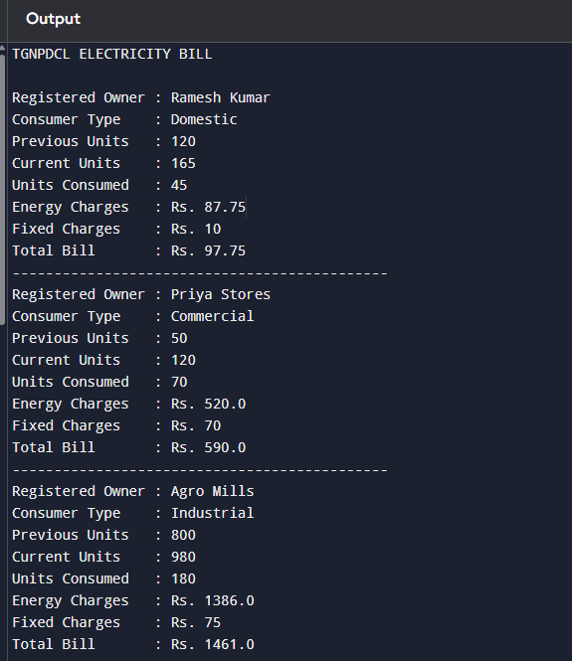
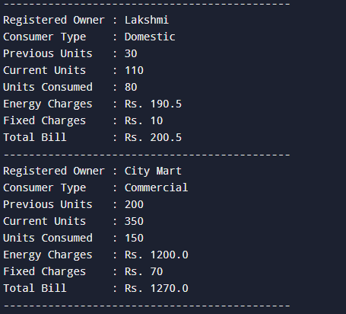
Task 4
Prompt
Task 4: Calculation of Additional Charges Scenario Electricity bills include multiple additional charges. Task Description Extend the program to calculate: • FC – Fixed Charges • CC – Customer Charges • ED – Electricity Duty (percentage of EC) Use AI prompts like: • “Add electricity duty calculation” • “Improve billing accuracy” ask any question if u need Expected Output • Individual charge values printed • Correct duty calculation • Well-structured output • Verified intermediate results
Code
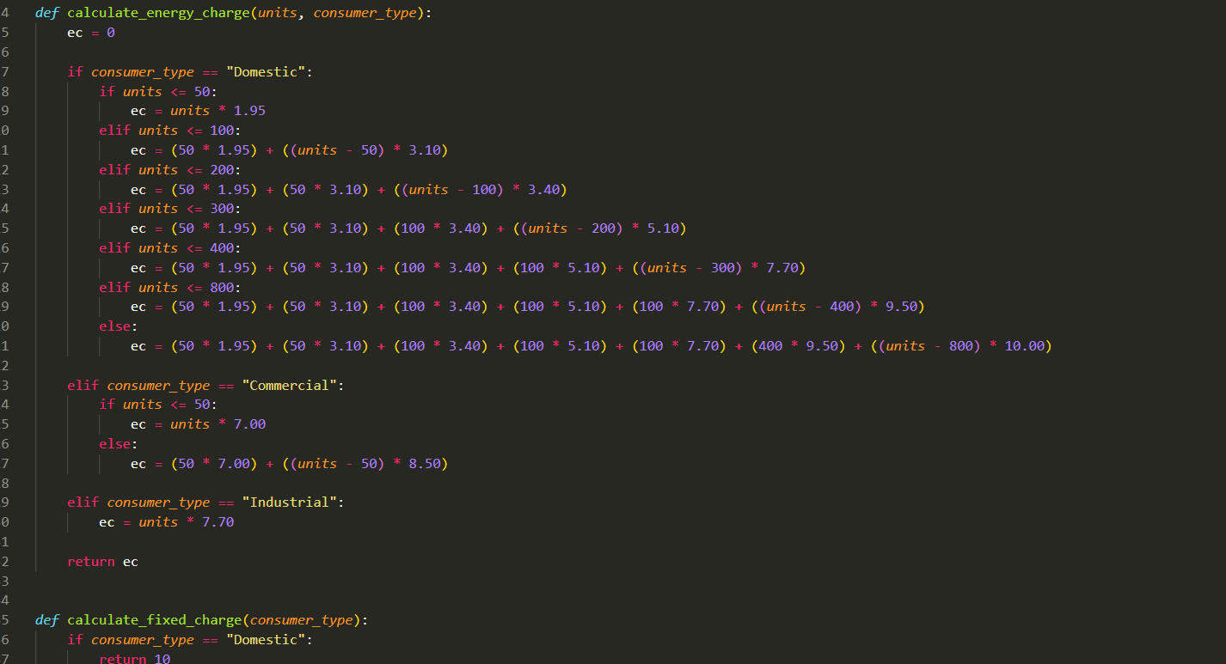
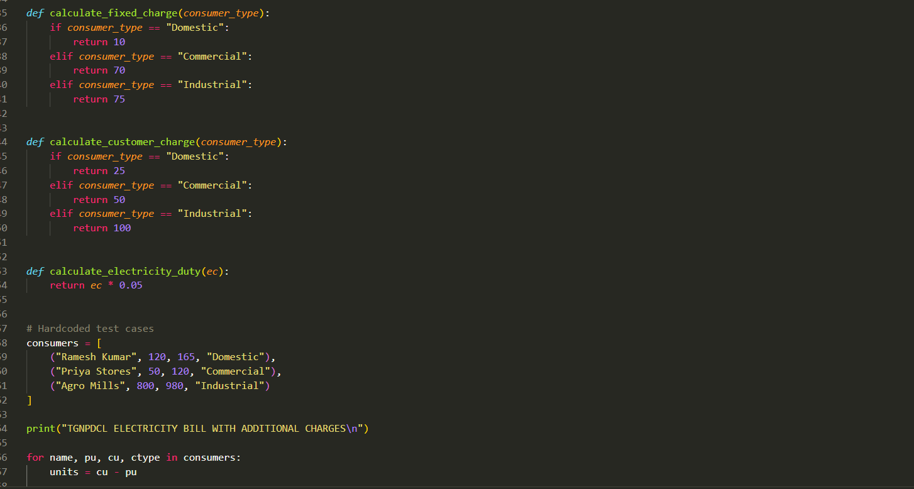
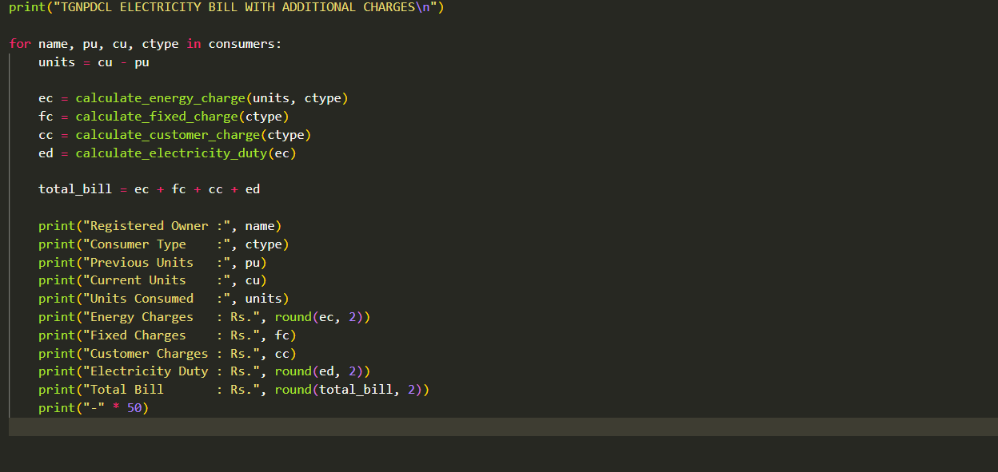
Output
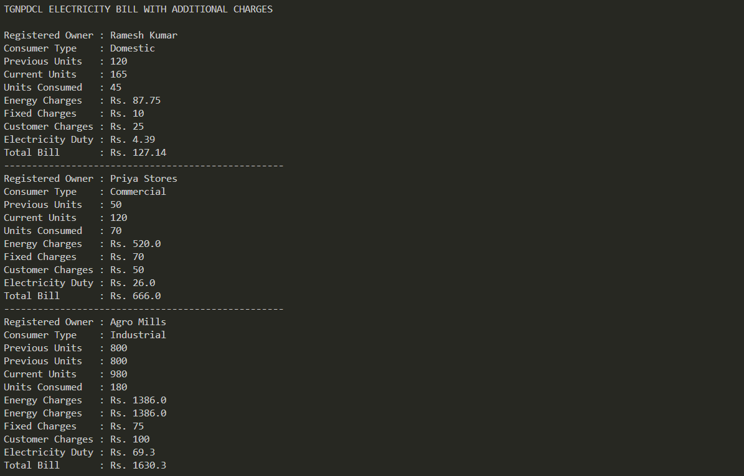
Task 5
Prompt
Task 5: Final Bill Generation and Output Analysis Scenario The final electricity bill must present all values clearly. Task Description Develop the final Python application to: • Calculate total bill: • Total Bill = EC + FC + CC + ED • Display: o Energy Charges (EC) o Fixed Charges (FC) o Customer Charges (CC) o Electricity Duty (ED) o Total Bill Amount • Analyze the program based on: o Accuracy o Readability o Real-world applicability Expected Output • Complete electricity bill output • Neatly formatted display • Sample input/output • Short analysis paragraph
Code
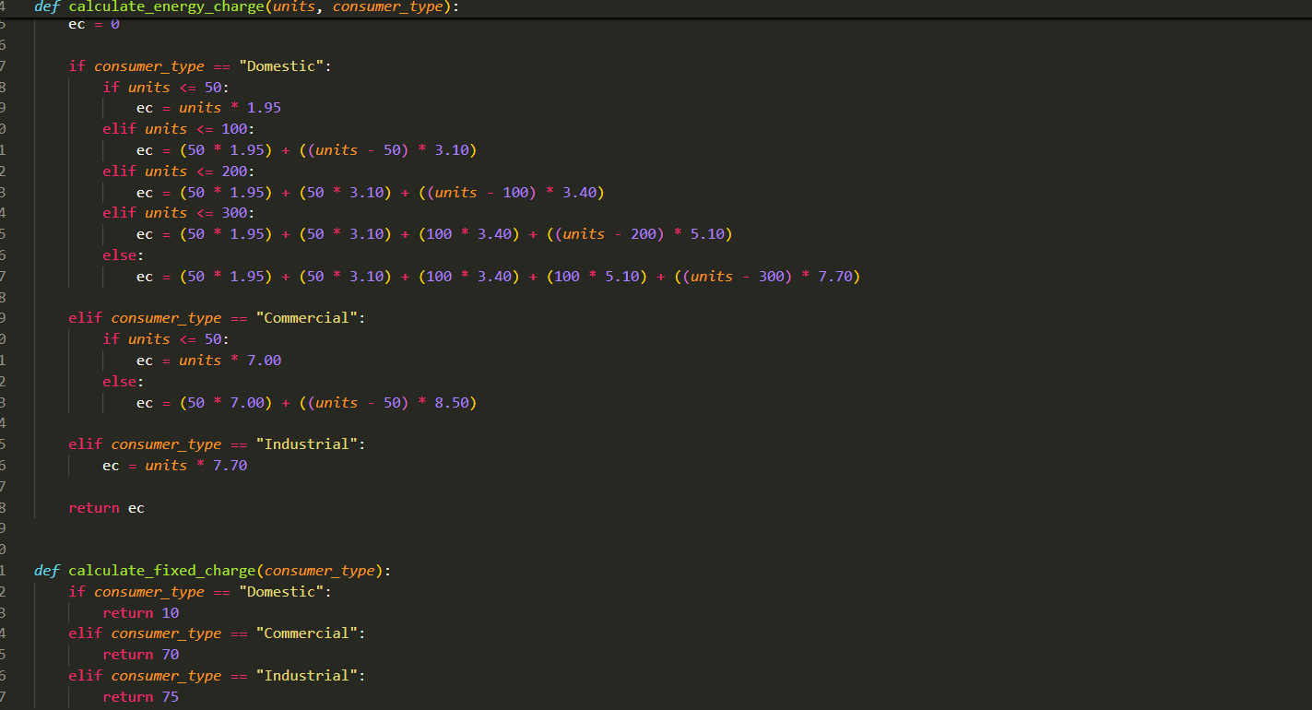
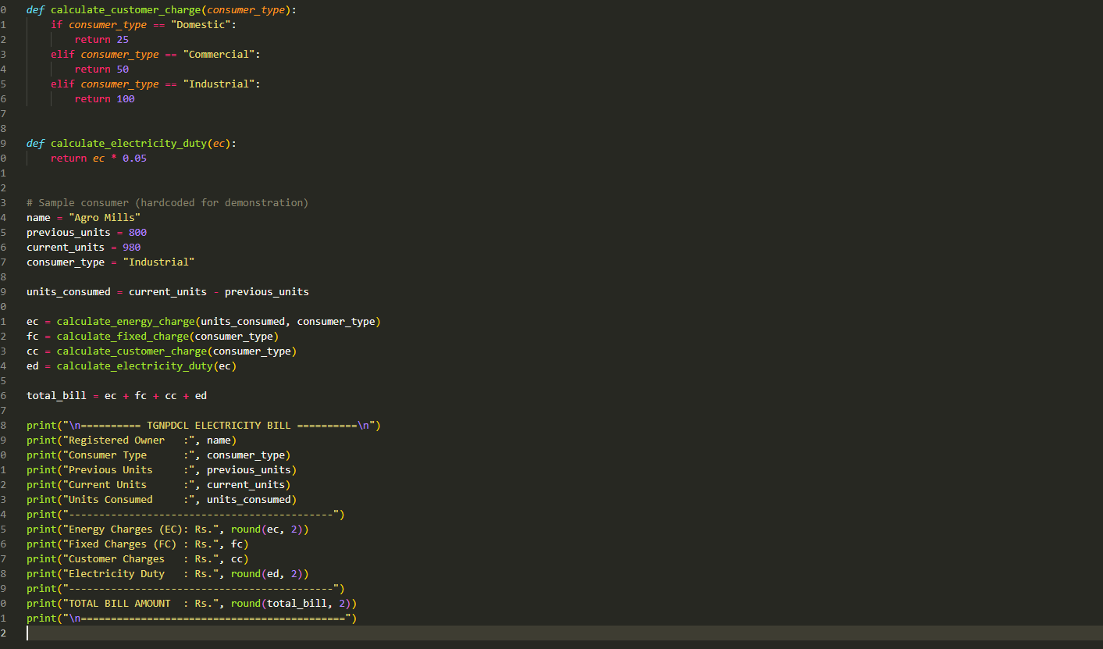
Output
